Updated By: | Curricular Affairs
Last updated: | 10/04/2023
Business Process Summary
Submitting a Course Modify Form through UAccess will result in the modification of an existing active course. Only the primary academic organization may submit the form. Please note that if content/learning outcomes are changing more than 25% then an inactivation and new course add will be needed to update the course.

Business Process Procedures:

Step A | Submitting a Course Modify Form
Please use the Course Catalog to review the current structure of the course before submitting a modification.
UAccess Administrative Login> Curriculum Management>Course Catalog>Course Catalog

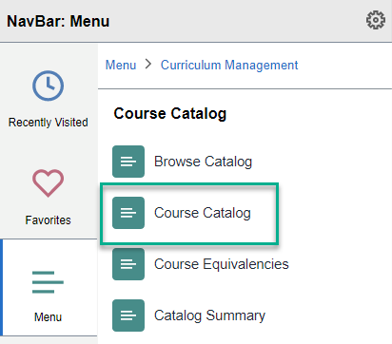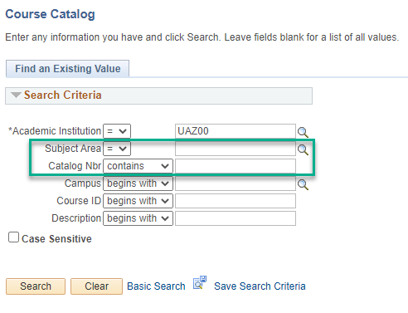
To submit a new UA Course Modify request please navigate to the modify forms in UAccess.
UAccess Administrative login> Navigator Bar> Curriculum Management> UA Curriculum Management>UA Course Management> UA Course Modify

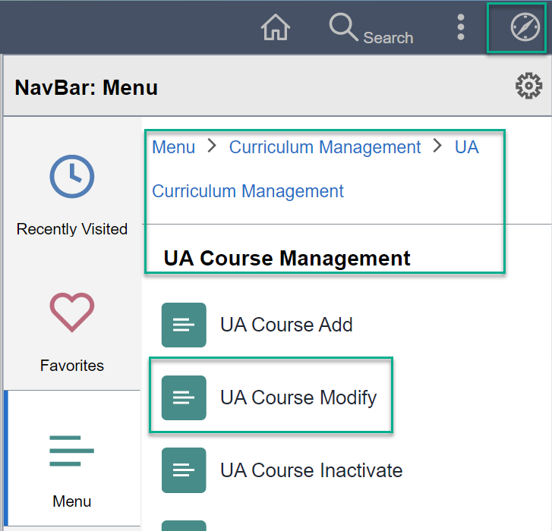

Click “Add a New Value” to start a new Course Modify Form.

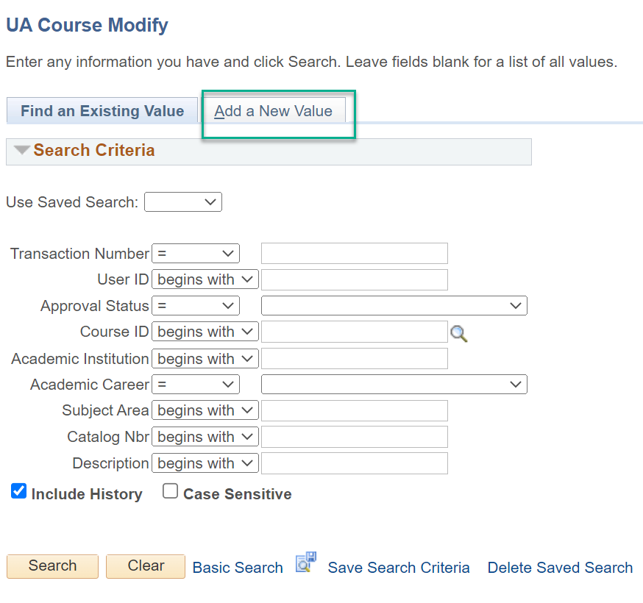

Enter the Course ID, and the fields from the course catalog will pull into the form for the displayed fields. If you do not have the course id the look up next to the field can be used to locate the course needed. (Note: search paramater on catalog nbr must be ‘contains’.”

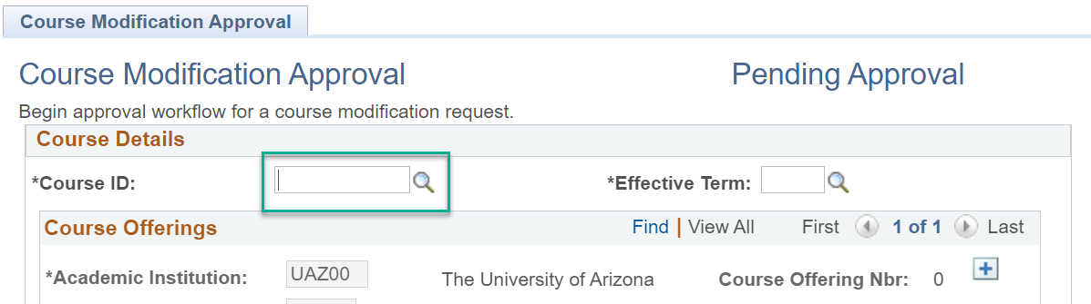

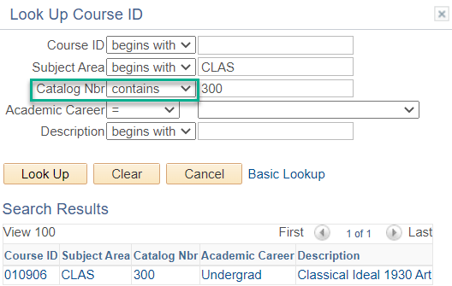

Fill out the first effective term, please use the Curricular Affairs website to follow the Course Approval Dates and Deadlines.

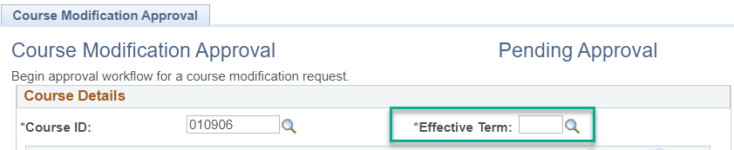

Items indicated with a green check-mark are editable:

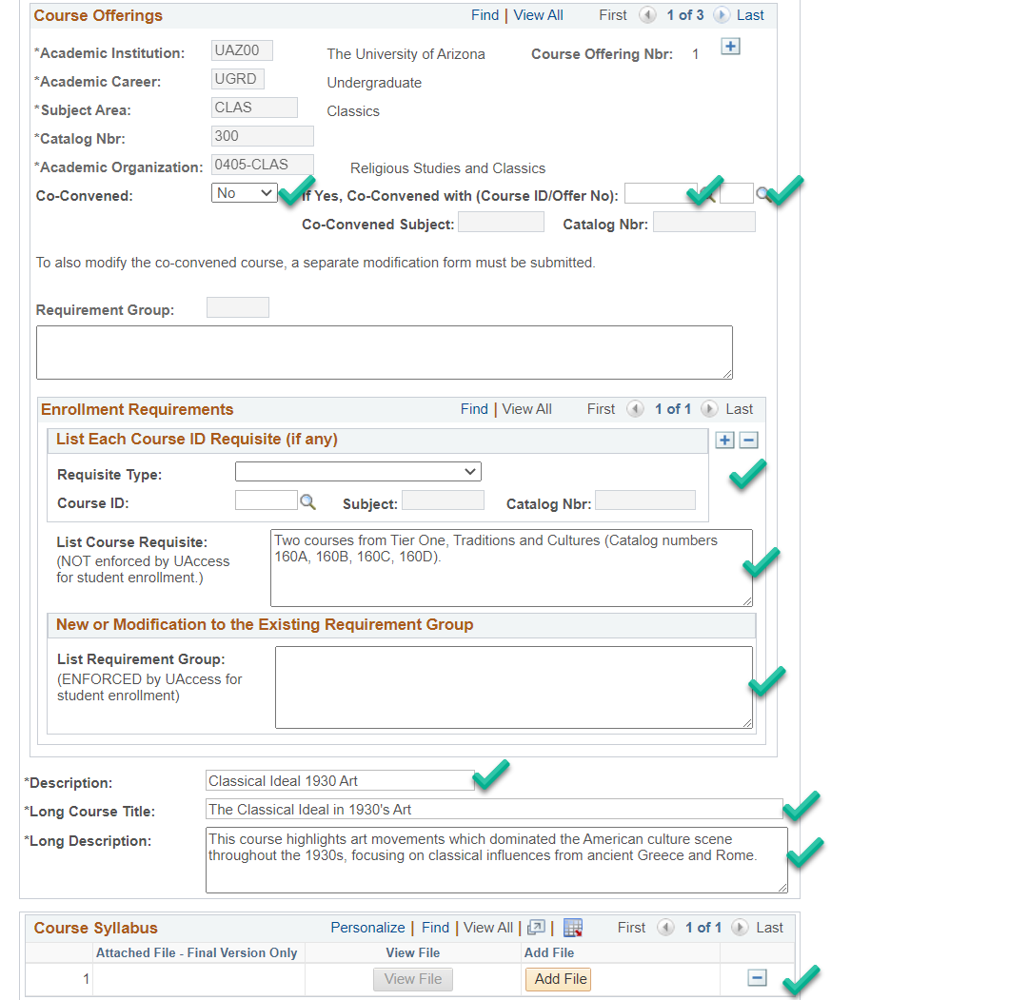

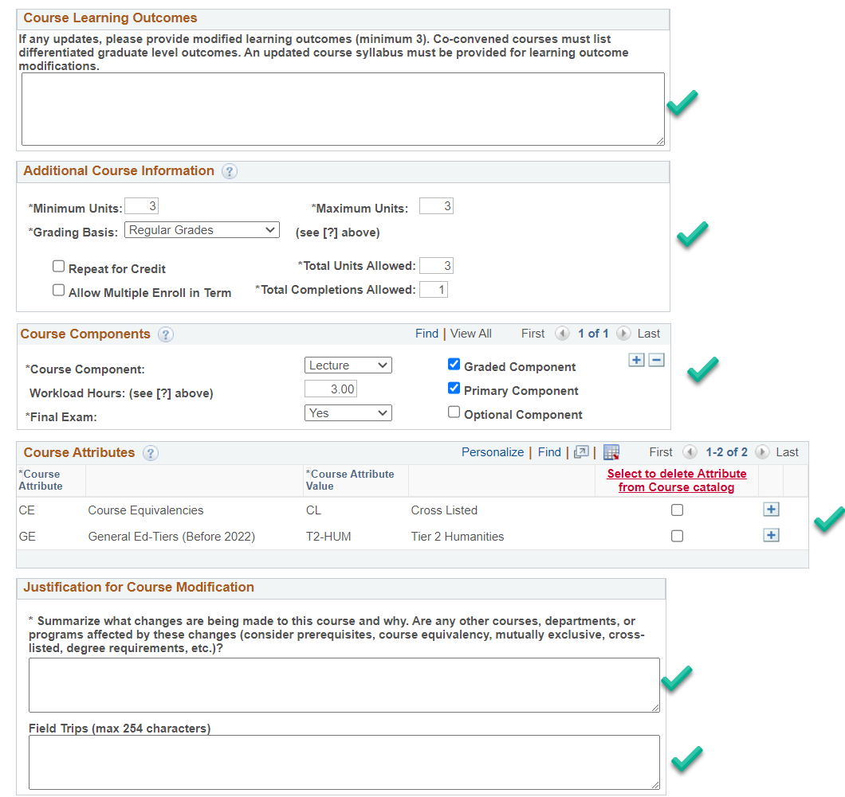

Syllabus needed:

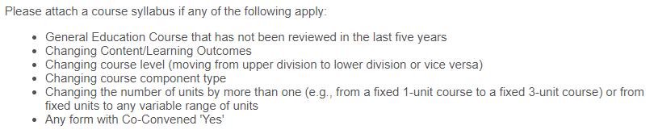
For modifications that are not directly in the field.

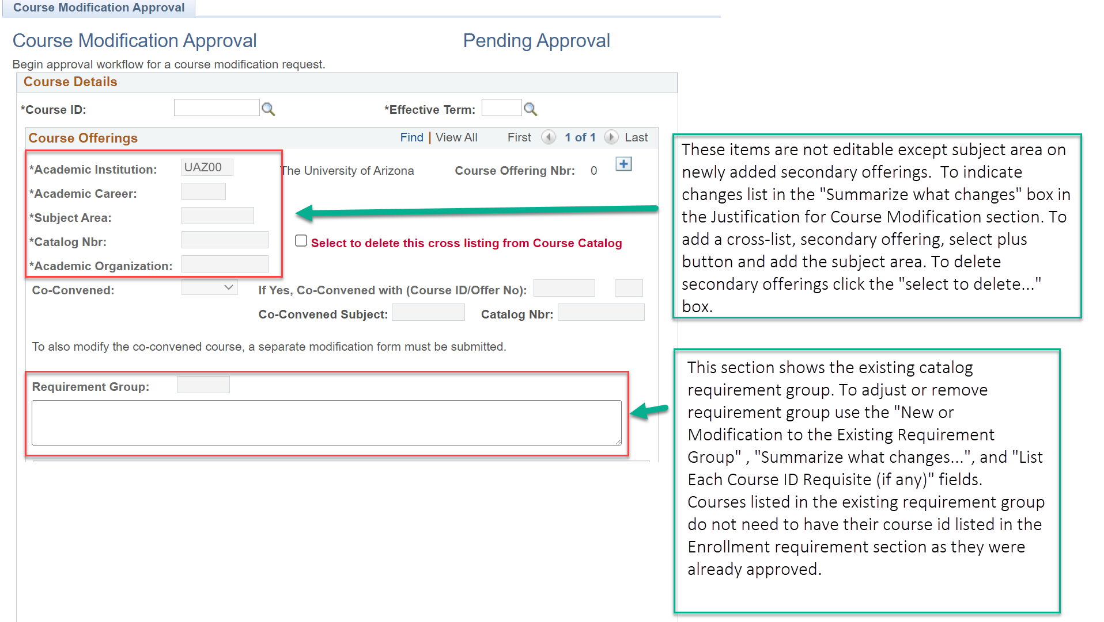

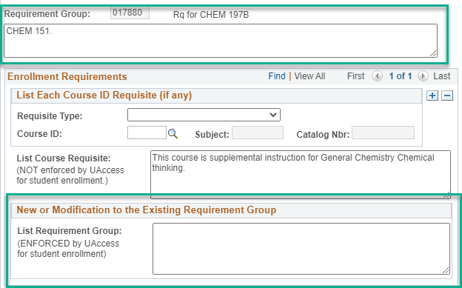

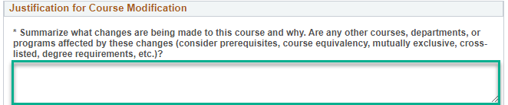

Modifications that can be requested using the summarize change section:

Typically offered: Use the course catalog to view existing typically offered information and then to adjust the existing catalog values go to the “summarize what changes…” field and list the campus and new value needed. Please be sure for DIST, SOUTH, PHX, ONLN, CMTY that the course being modified is approved for use in a program offered on the desired campuses before submitting typically offered value changes to add new campuses that were previously listed as not offered.

Course Owner: The primary offering, offering 1, is the course owner. To change the primary offering of a course to another department there are a couple of ways to indicate this change.

  - If a course is already cross-listed and one of the existing secondary offerings will become the new owner, please go to the “Summarize what changes…” box on the form and state what subject will become the new primary offering and then list if the current primary offering should become a secondary or be removed.
  - If the new primary offering is not currently on the form please use the CE-CL attribute and the offering section + button to add the subject for the new primary offering and then use the “summarize what changes” box to specify the new primary offering and if the current primary offering will become a secondary or if it should be removed.
  - If unable to add the new primary offering subject due to that department having an existing catalog number please use the “summarize what changes” list the new primary offering subject and specify if the current primary offering will shift to a secondary offering or be removed. List a new catalog number in the summarize section. Please be sure to check that the number being used does not have an active course attached to it in the course catalog. See note below before submitting.

**NOTE: Catalog numbers may not be reused if there have been enrollments in the last 8 years.

Undergraduate courses changing level through a catalog number adjustment require an inactivation and new add.

Example: CLAS 260 requesting to change to CLAS 460.

If a catalog number is being adjusted to cross-list or co-convene, and there is no level change for the undergraduate course, then list the catalog number change needed.

Example: CLAS 455 and CLAS 555 changing to CLAS 466 and CLAS 566 to add DATA as a cross-list

Be sure there is one form per Course ID, so for the above there should be 2 modify forms.
Once the form is complete, please save and then select submit.
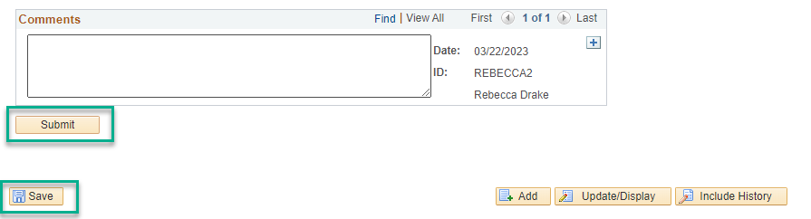

Please note: If you pasted text such as a description or learning outcomes from a source document with varying punctuation markings please save and use the transaction nbr to go out of and then re-enter the form. This adjusts to source format to the form format. You can then edit any formatting changes. These typically show as ‘¿’. Once the formatting issues are corrected, please select save and then submit.

Please be sure all modifications are done as needed prior to the submit button. If you are waiting on responses from your instructor or department you can save the form and come back to it. Please only select “submit” once the form is finalized.
Tracking UA Course Modify Forms

Course Initiators(requestor):

You are responsible for using UA Course Management to monitor the progress of the Course Forms you have submitted and will need to follow-up if there are questions or concerns. Please view all comments before contacting approvers. Please check Dates and Deadlines on the Curricular Affairs website to be sure forms complete their route by the final approval deadlines.

Form Approval Steps
Every step has different approvers and some only appear if certain criteria are met. Here are the steps:
- Curricular Preview
- Department
- Xlist Department(cross-list or pre-req course are listed)
- College
- Xlist College(cross-list or pre-req course are listed)
- Grad(if career is GRAD)
- Hnrs (HNRS attribute is included)
- Gened(SSCS or GEED/GEAT/GEFN attribute are included)
- RCS Approval(Curricular Affairs Final approval, name change was placed on hold)

To check your course modify forms currently routing search you can use UA Manage Course Forms “My Other Forms”, or use UA Course Modify and search by your NetID and the Approval Status “In-Process”. If the forms were not submitted by you the other search parameters may be used.

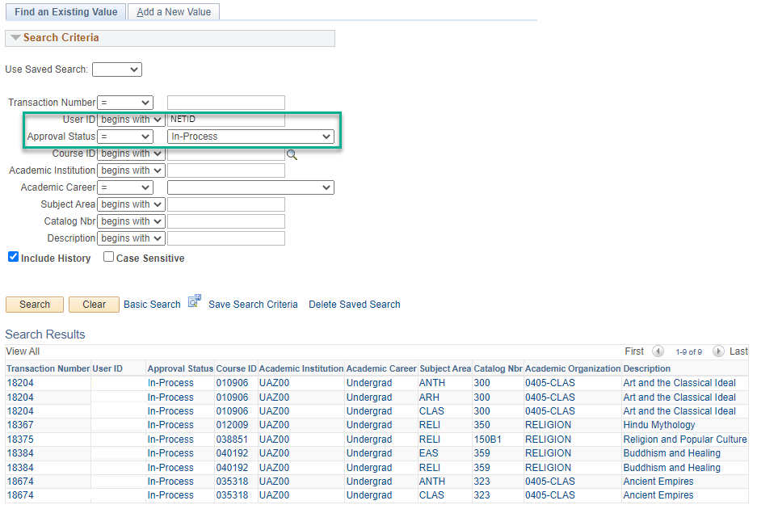

Example route: The stages marked in Green for the UA Couse Modify form are the Curricular Affairs-Course Approvals approval stages. The first is the Preview stage and the last is the final approval stage. Please contact courseapprovals@arizona.edu if there are inquiries on those stages.
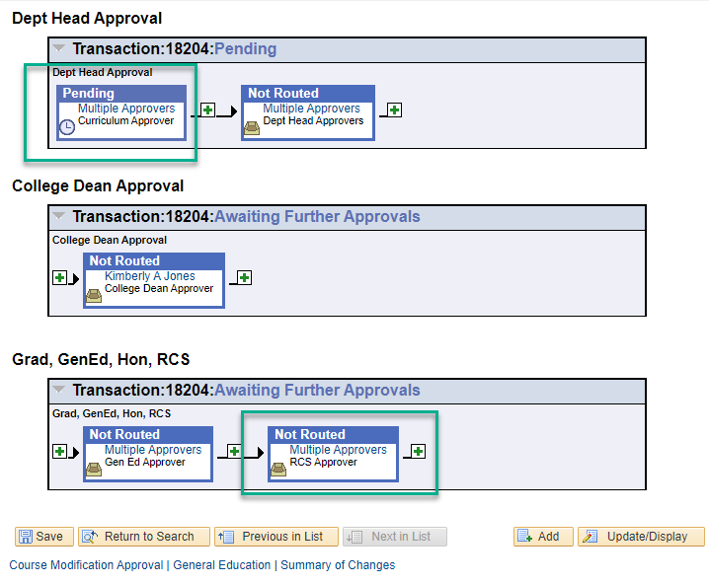

For all other stages please see the approver listed or select “multiple approvers” and the approvers provisioned for the step will appear. The UA Phonebook may be used to locate approver emails if you are unable to find them in your email directory.

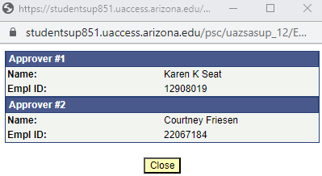

If an approver is no longer at the UA or in your department/college, please work with the appropriate business manager or administrative staff in your department/college to submit a UAccess provisioning add to provision the new approver and once in place an removal for the old approver. Once the provisioning add is completed, if there are any forms in-process(on the approval stage for the updated approver) and the new approver is missing with no backup approvers that can approve the form, please reach out to Curricular Affairs-Course Approvals, courseapprovals@arizona.edu , to have the new approver swapped into the approval step.

If a step says skipped and a new approver has not been provisioned for the access role, the form will be returned to the department with a comment to provision the missing department or college approver for their subject. Provisioning to gain role access to any UAccess access role is done on the UAccess Homepage, https://uaccess.arizona.edu/ through AccessFlow.

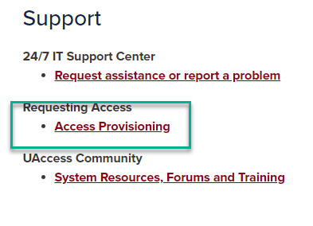

Step B | Specific Form Field Details
Enrollment Requirements | Requirement Group needs to have only system enforceable requisites such as courses, majors, minors, certificates, placement exams, student groups, GPA, etc… These items are located on the student record and can be used to stop enrollment if criteria are not met.  Course Requisites field is text only and is for requisites/notes that cannot or should not be enforced by the system.  New or Existing requirement group: Must edit using the New or Modification to the Existing Requirement Group by adding directly into the text box and if new courses are included use the List Each Cour ID Requisite (if any) section to add all new course ids to be enforced in the requirement group.  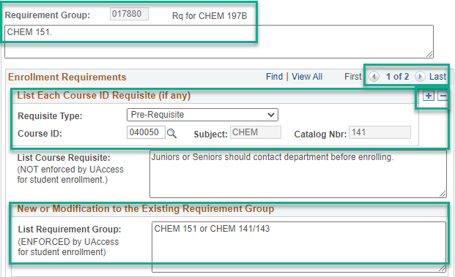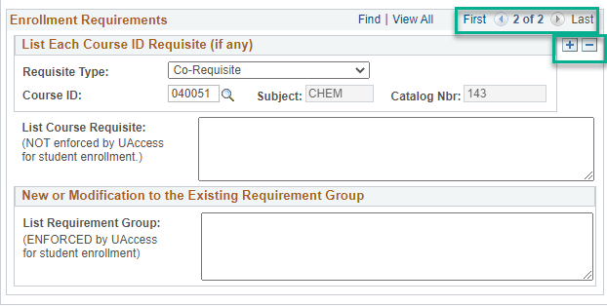  When updating requirement groups it is not necessary to add existing courses to the Course ID section, i.e. you would not add CHEM 151 as it was already approved for use, but you would add the new 141 and 143. When adding additional courses select the plus button on List Each Course ID Requisiste(if any) and then add the requisiste type and course id. The course requisiste and requirement group information is on the 1 of 2 record, so it is not necessary to add the information on each cours tab added.  Existing course requisite: Can edit directly in the text box.  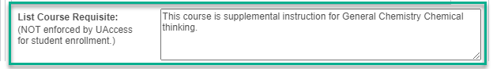  Note: The list Course ID section is for courses that need to be added to an enforced requirement group. For un-enforced Course Requisite use please leave blank.  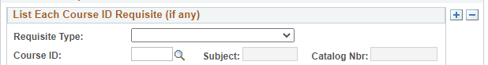
Syllabus | Inserting a course syllabus: Review the list of when a syllabus is needed before adding a file. If a syllabus is required, please click “Add File” and insert your .doc or.pdf file.  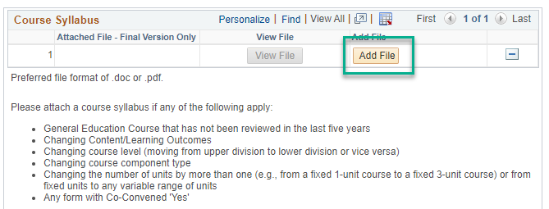
Course Attributes | If there are Course Attributes associated to the course, each Course Attribute also has a Course Attribute Value needing to be added. Existing attributes will pull into the form from the Course Catalog and can be removed by selecting the delete box marked in red below. To add attributes, use the selection lookup next to the course attribute and once entered then use the lookup on the Course Attribute Value to enter the needed value. If more than one attribute is needed, please use the plus button indicated in green. If an item you added to the form being worked on needs to be removed, or you accidentally added a blank row, use the minus button indicated in green below to remove the unneeded row.  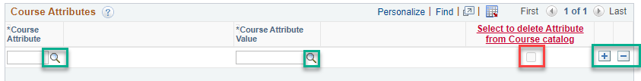  Attributes with additional actions needed:  - SEC or SEA- if either are selected the other must be added. Engagements must have both competency and an activity attribute.  - GEED or GEAT- Minimum must have one GEED and one GEAT attribute. These are General Education attributes, and the General Education tab will appear at the top of the form when selected, if the course is newly transitioning to GENED, has not been reviewed in 5 or more years, or you are changing something on the General Education tab the tab must be filled out. If your course was recently reviewed and you are not changing the specific fields on the GENED tab please list “NA” in all fields marked required fields on the tab that are not being altered.  For full details on the General Education tab completion please visit GE Course Proposals | General Education Refresh (arizona.edu)  - CE-CL- Must select the plus button on the offering section of the form and add the new subject for the secondary offering. If there is an issue with existing catalog numbers please notate the needed subject, new catalog nbr, and attribute in the summarize section.  - CE-EQ- Must provide the courses with 70% content overlap with the course being modified and summarize why the equivalency group is needed in the summarize change section.  - CE-ME- Must have an anti-requisite in the new or modification to requirement group section of the form and the course ids for the other course(s) involved and requisite type must be listed in the course id section of the Enrollment Requirements portion of the form. List the explanation of how the courses are mutually exclusive in the summarize section of the form.  - SSCS-SCS- Fill out the success course tab. For questions reach out to the General Education office.  - GEFN- Foundation courses must be discussed with the CA director before submission. Please email Curricular Affairs at curricular_affairs@list.arizona.edu before submitting a modify to add the GEFN attribute to a new or existing course.  - WE-WEC- Must show that 60% of the course grade must be based on written work. See the General Catalog for policy requirement, https://catalog.arizona.edu/policy/program-graduation/general-education/writing-emphasis.
Co-Convened | If a new co-convene, please change Co-Convened to ‘Yes’ and if an existing course is the co-convene list the course ID and offering nbr 1. If co-convened with a new course being routed, please list ‘Yes’ and then indicate the co-convened course in the summarize section.  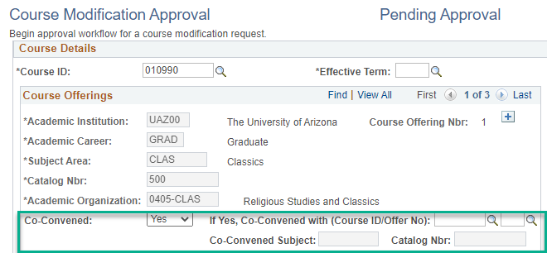’  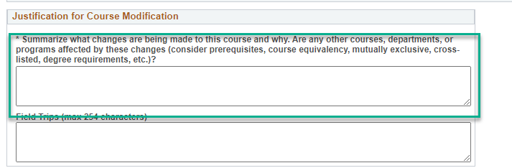  Please note: One form per course/course id is needed for co-convened courses as there are, or will be, two different course ids involved. For example, if the modification is for the 400 level and the 500 level is an existing course, please submit a 500-level modification as well to add the co-convene designation. If the other course is a new course add form that was submitted at the same time as the modify, then no action is needed. If the other course is a new or modify that was already submitted and is routing, depending on where it is in the route the department may want to wait for it to complete its route and then request a co-convene, however if the department chooses the new add or modify can be returned to the department and the co-convene information added and then both forms routed together.
Learning Outcomes | If more than 25% of the course content/learning outcomes are changing an inactivation and new add forms are needed instead of a modify form. A good question the instructor can ask is if a student that previously took this course attempted to GRO would they recognize most of the course content?  Please only provide updates in the learning outcome section.  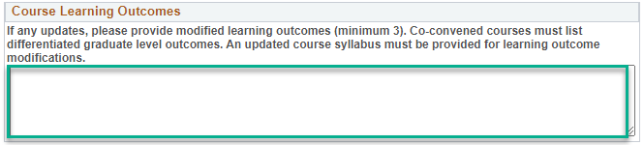  In the summarize change section please indicate what the changes are, i.e. slight rewording or 1 new learning outcomes, removing 1 learning outcome and if there are content changes or not. If content changes, please be sure it is less than 25% of the content/learning outcomes.
Repeat for Credit | Repeating a Course: Taking the same course to attempt to improve one’s grade. The content is the same and no additional credit is given. See General Catalog-Repeating a Course for full details on repeating a course and the limitations.  Repeat for Credit: Courses taken more than once for additional credit. The course content must change each time taken. i.e. special topic house numbered colloquium, seminar, workshop, and individual study courses. Outside the house numbers fixed multiple topic courses, i.e. CRL 101, and studios may be repeat for credit.  The learning outcomes should be the same each time the course is offered but may include some additional learning outcomes that are topic specific for special topic courses.  Allow Multiple Enroll in Term: allows students to take more than one section of a repeat for credit course in the same semester. Graduate College does not allow multiple enroll in term to be selected for 909, 910, and 920 courses.

