Updated By: | Curricular Affairs
Last Updated: | 10/04/2023

Business Process Summary
Submitting a Course Inactivation Form through UAccess for courses that are no longer going to be offered within the department’s curriculum moving forward. Inactivating a Course does not mean deleting Course ID’s, as historical records remain logged in the Course Catalog. The status of the course will be changed to inactive and the course will no longer be available to schedule sections in the Schedule of Classes.

Business Process Procedures:

Step A | Checking for Live Sections
Check the Schedule of Classes to make sure there are no active sections of the corresponding Subject and Catalog Number for the effective term being requested. Please go to the UAccess Homepage:
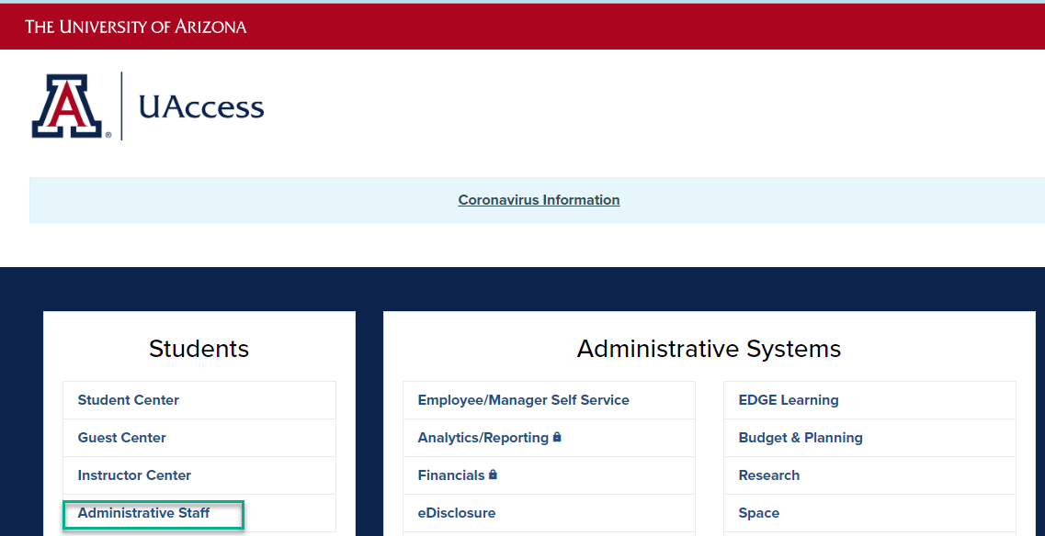

Use the navigator menu to go to locate the schedule of classes, Curriculum Management>Schedule of Classes>Maintain Schedule of Classes or UA Schedule of Classes Update.
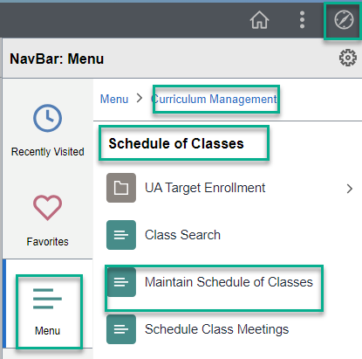

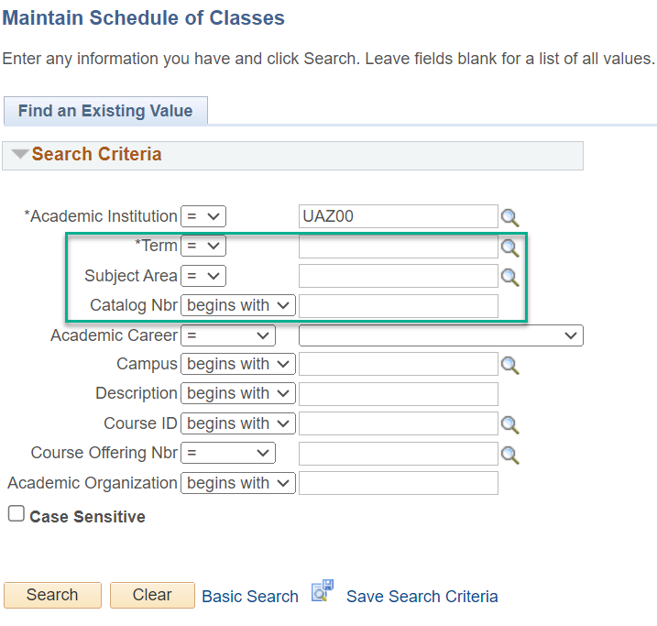

**If there are active sections make sure to delete/inactivate them before submitting the Course Inactivate Form. If there are live sections when the form reaches final approval the form and any related forms will be moved to the next available term.

Step B | How to Submit a Course Inactivate Form
Navigate to the Course Catalog Add Forms in UAccess:
UAccess Administrative login> Navigator Bar> Curriculum Management> UA Curriculum Management>Course Management> UA Course Inactivate.

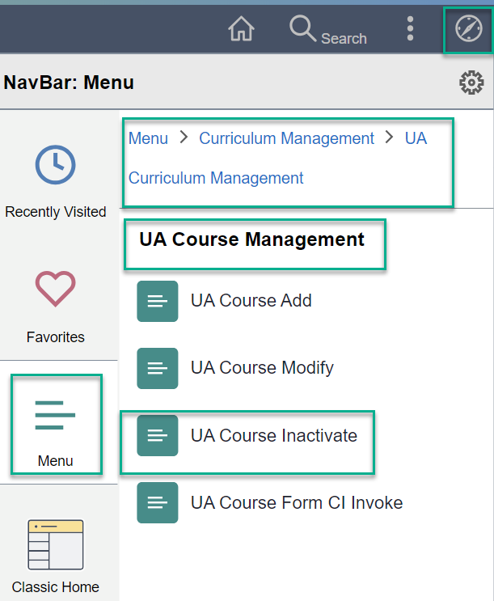
Click “Add a New Value” to begin a new Inactivate Form.

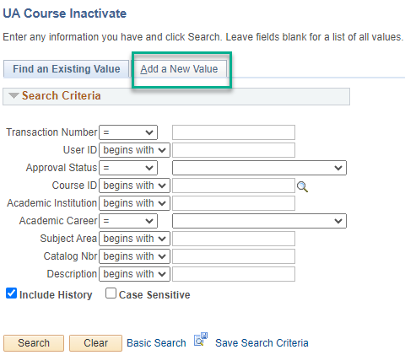
Input the Course ID.

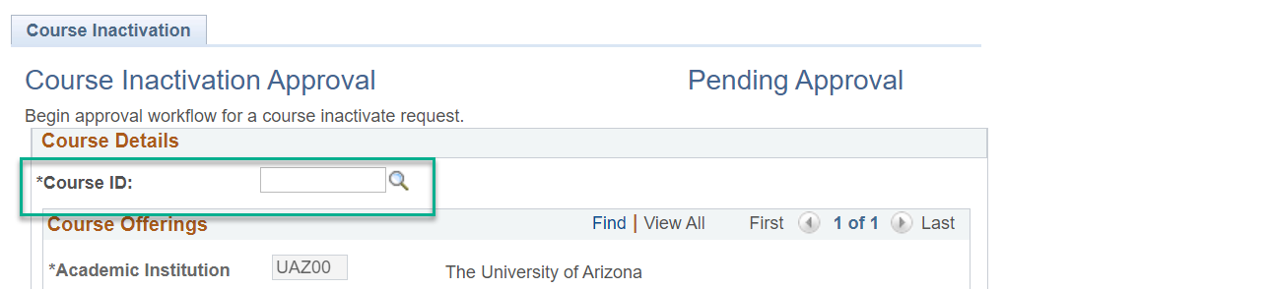

Once the Course ID is inputted, the form populates information from the course catalog.
If inactivating a co-convened course please fill out the following:

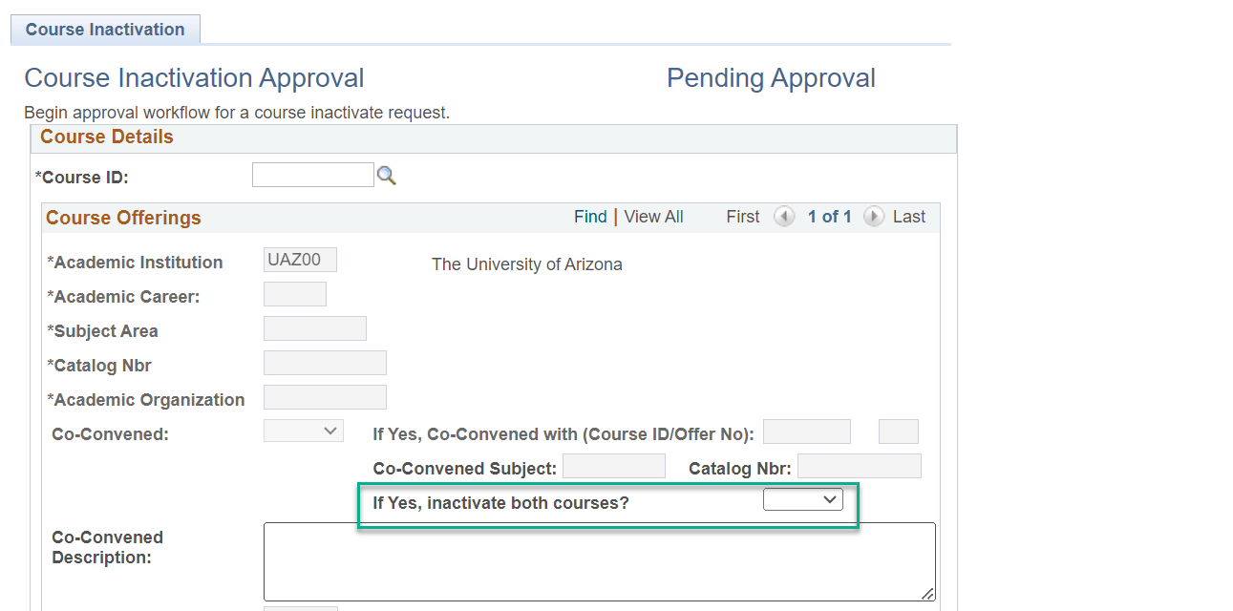

If Yes, please be sure to submit an inactivation for the co-convened course id as the 400 and 500 levels will have their own unique course id and one form per course id is required.
If No, please send a UA Course Modify form to update the co-convened course id information to remove the co-convened designation and adjust the course to remove the grad or undergrad information depending on the level being inactivated.

Please provide the reasons why the course is being inactivated and fill in the First Effective Term.
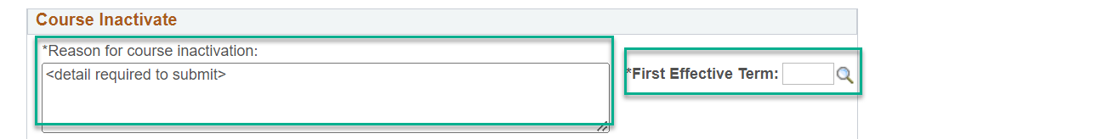
If this is tied to a new add please list the transaction number for the course add form so the forms will be processed together.
Consider the impact of the course being inactivated and list the other courses affected by this inactivation. Inactivating a course may impact majors or minors, course requisites or enrollment requirement groups for multiple departments. It is the responsibility of the individual departments to submit modification forms for changes to course requisites and enrollment requirement groups. The following section is for departments to note the impact of the inactivation and should submit any course modify forms and curriculum update forms tied to items listed below.

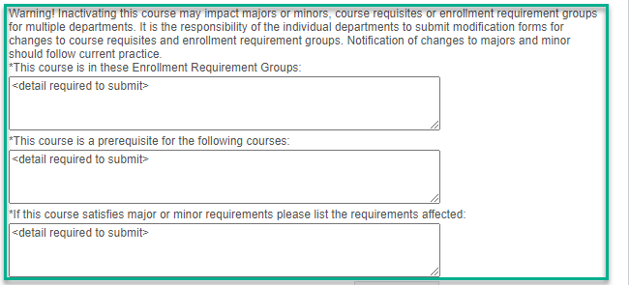

 | The below is rarely used and can be left blank. Reach out to courseapprovals@arizona.edu before use.
Provide any additional information necessary.


Select submit to send form to Curricular Affairs for preview and route start.
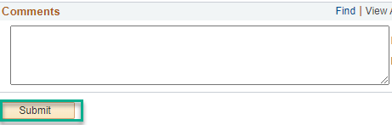
Tracking UA Course Inactivate Forms

Course Initiators(requestor):

You are responsible for using UA Course Management to monitor the progress of the Course Forms you have submitted and will need to follow-up if there are questions or concerns. Please view all comments before contacting approvers. Please check Dates and Deadlines on the Curricular Affairs website to be sure forms complete their route by the final approval deadlines.

Form Approval Steps
Every step has different approvers and some only appear if certain criteria are met. Here are the steps:
- Curricular Preview
- Department
- Xlist Department(cross-list or pre-req course are listed)
- College
- Xlist College(cross-list or pre-req course are listed)
- Grad(if career is GRAD)
- Hnrs (HNRS attribute is included)
- Gened(SSCS or GEED/GEAT/GEFN attribute are included)
- RCS Approval(Curricular Affairs Final approval, name change was placed on hold)

To check your course inactivate forms currently routing search you can use UA Manage Course Forms “My Other Forms”, or use UA Course Inactivate and search by your NetID and the Approval Status “In-Process”. If the forms were not submitted by you the other search parameters may be used.

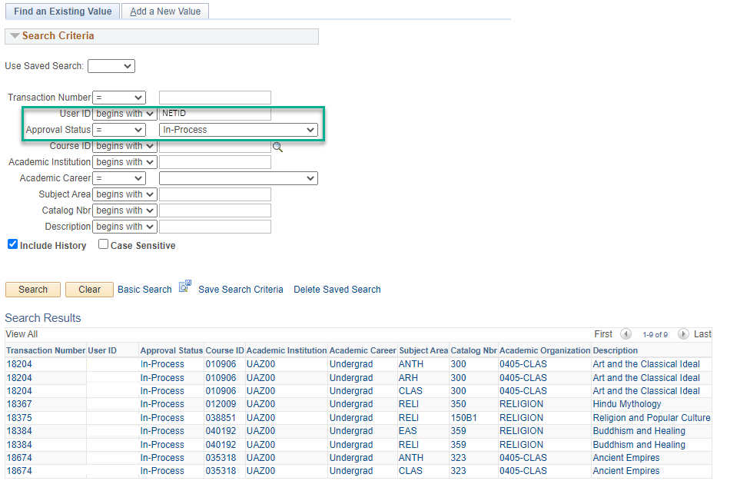

Example route: The stages marked in Green for the UA Couse Inactivate form are the Curricular Affairs-Course Approvals approval stages. The first is the Preview stage and the last is the final approval stage. Please contact courseapprovals@arizona.edu if there are inquiries on those stages.
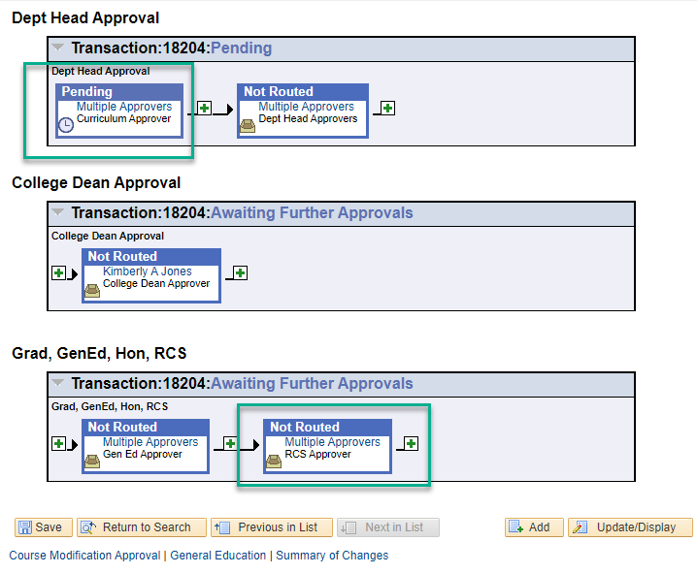

For all other stages please see the approver listed or select “multiple approvers” and the approvers provisioned for the step will appear. The UA Phonebook may be used to locate approver emails if you are unable to find them in your email directory.

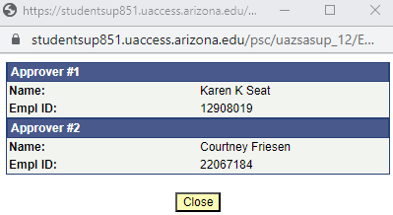

If an approver is no longer at the UA or in your department/college, please work with the appropriate business manager or administrative staff in your department/college to submit a UAccess provisioning add to provision the new approver and once in place an removal for the old approver. Once the provisioning add is completed, if there are any forms in-process(on the approval stage for the updated approver) and the new approver is missing with no backup approvers that can approve the form, please reach out to Curricular Affairs-Course Approvals, courseapprovals@arizona.edu , to have the new approver swapped into the approval step.

If a step says skipped and a new approver has not been provisioned for the access role, the form will be returned to the department with a comment to provision the missing department or college approver for their subject. Provisioning to gain role access to any UAccess access role is done on the UAccess Homepage, https://uaccess.arizona.edu/ through AccessFlow.

